Purpose / Scope:
Timing and action plan for customer data, engineering levels, revisions and the part-tool-gauge-equipment relations of all KTX Toccoa projects in PLM2. Standards: IATF 16949 7.5.3, 7.5.3.2.1, 7.5.3.2.2, 8.5.2, 8.5.2.1.
Owner / involved:
- C. Demmler, Process Development: owner of PLM2 and of every action in this plan, author, keeps it current
- Program Management and APQP: support (specification, tests, pilots on the running projects, evidence)
- Departments named per action (IT, Quality, Development, Tooling, HR, department heads): support where their part is needed
- Plant Management: monthly status review
1. Summary
Traceability, engineering level and the data itself are already tight in PLM2: every part carries its revision history with engineering level and customer index, every change is written to a tamper-evident audit trail, and part, tool, gauge and equipment are linked as system data. The module is in development for the remaining functions below; go-live, meaning network drives become read-only for active projects, is 03/22/2027.
2. Requirements and how they are met
Requirement | How it is met | What we show
Control of documented information (7.5.3) | One active revision per part; older revisions stay in the history, read-only | Part page, revision list
Engineering specifications, review of customer changes (7.5.3.2.2) | Every new customer index enters intake; Development decides: administrative, engineering review or full change | Intake list, decision with reason
Record retention (7.5.3.2.1) | Revisions are superseded, never overwritten; every data change in the audit trail; database backed up before every data operation | Revision history, backup log
Identification and traceability (8.5.2, 8.5.2.1) | Part numbers by family, tool and gauge numbering (tool-operation), relations with where-used and BOM | Where-used of a tool, e.g. 3360

3. Process flow
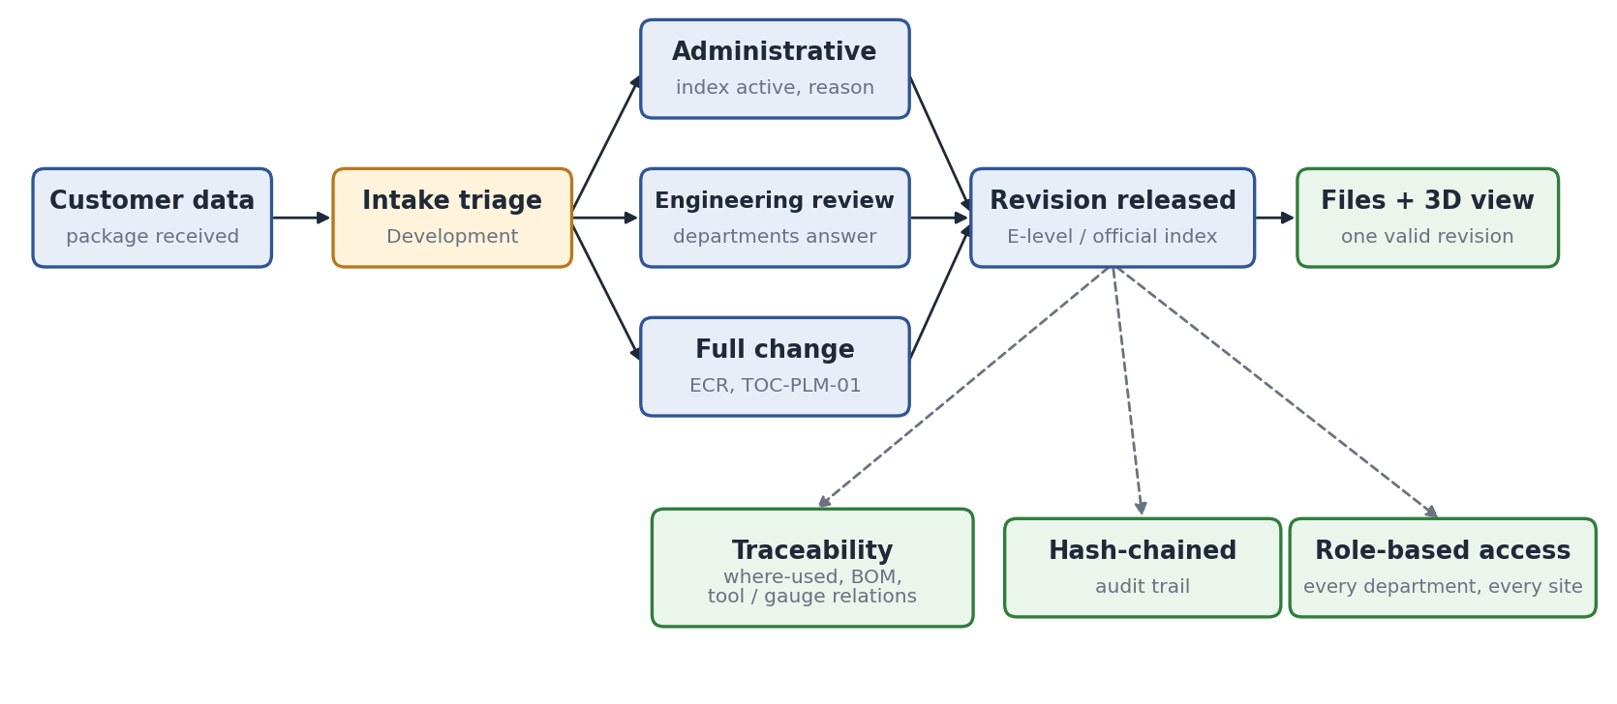
- Levels: E1, E2 = customer review data; 1, 2 = official customer data; x.1 = own proposal. Shown as 'E2 · B' (our level · customer index). Counters never reset, so every level is unique.
- Relations: a tool produces articles, a gauge checks them, equipment serves the tool; mirror parts are relations, never copies.
- Legacy data: the former system (WinCarat) was imported once and is read-only; PLM2 is the master since.
4. Where we stand today
Element | Status | Evidence in PLM2
Revision and level scheme, customer package receive | Built, tight | Part page of any series part
Hash-chained audit trail on parts and changes | Built, tight | Part changelog
Relations part-tool-gauge-equipment, where-used, BOM | Built, tight | 1,337 tool-article links; 152 gauges and 14 equipment linked
3D view of customer data (STEP) | Built | Viewer on the revision
Review deadline for customer data (10 working days) | In development | Action M2
Completeness: gauges without tool, customer part numbers | In development | Actions M3-M4
Access scope on every list | In development | Action M1

5. Tightening points
Today | Tightening measure | Action | Due
Drawings and customer data partly still on network drives | Transfer per active project; drives read-only after go-live | M6, F2 | 03/22/2027
Review time of customer data not measured | Intake timer with overdue signal at 10 working days | M2 | 11/27/2026
Some records incomplete (gauges without tool, customer part numbers) | Completeness list, closed per project | M3, M4 | 01/04/2027
Backup before data operations, not yet scheduled | Scheduled backup with documented restore test | M5 | 11/20/2026

6. Timing and action plan
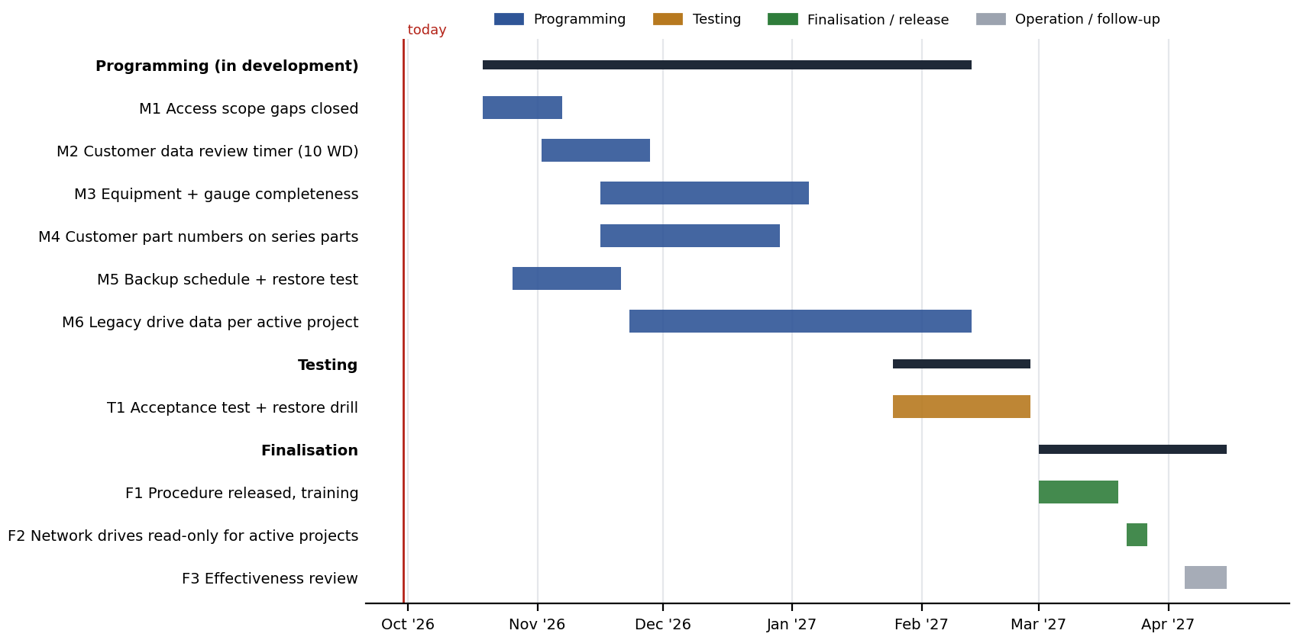
No. | Action | Phase | Owner | Support | Due | Done when
M1 | Access scope closed on all lists (SEP, lessons) | Programming | C. Demmler | Program Mgmt., APQP | 11/06/2026 | Scope test per role passed
M2 | Customer data review timer, 10 working days, overdue signal | Programming | C. Demmler | Development | 11/27/2026 | Timer on intake list
M3 | Equipment and gauge completeness (tool link, equipment details) | Programming | C. Demmler | Tooling, Quality | 01/04/2027 | 0 gauges without tool
M4 | Customer part numbers on all series parts; one mirror per part | Programming | C. Demmler | Development | 12/28/2026 | Completeness list empty
M5 | Scheduled database backup and restore test | Programming | C. Demmler | IT | 11/20/2026 | Restore test record
M6 | Transfer legacy drive data of active projects | Programming | C. Demmler | Development | 02/12/2027 | Per-project checklist signed
T1 | Acceptance test and restore drill | Testing | C. Demmler | Quality, IT | 02/26/2027 | Signed test protocol
F1 | Procedure 'Engineering data management in PLM2' released, training | Finalisation | C. Demmler | Quality | 03/19/2027 | Procedure; training per concept (TOC-PLM-01 TR)
F2 | Network drives read-only for active projects | Finalisation | C. Demmler | IT | 03/22/2027 | Drive rights changed
F3 | Effectiveness review | Operation | C. Demmler | Quality | 04/14/2027 | Review in management review

The table is the plan as of the status date above. Progress is tracked in the action plan TOC-PLM-LOP (KTX LOP F-DVS-CORP-010); a date that moves is changed there with the reason, and this document is updated with it.
7. Control until go-live
Until 03/22/2027 the valid revision of a part is the one released in PLM2; files still on drives are reference copies. New customer data is received in PLM2 only.
8. Effectiveness indicators
Indicator | Target | Source
Customer data reviewed within 10 working days | 100 % | Intake list
Parts / tools / gauges with incomplete data | 0 for active projects | Completeness list
Successful restore tests | 1 per quarter | IT backup log

